**DAILY ONLINE ACTIVITIES SUMMARY**

|  |  |  |  |  |  |  |  |  |
| --- | --- | --- | --- | --- | --- | --- | --- | --- |
| **Date:** | **20-06-2020** | | | | | **Name:** | **RACHANA K N** | |
| **Sem & Sec** | **6th  Sem ‘B’ Sec** | | | | | **USN:** | **4AL17CS070** | |
| **Online Test Summary** | | | | | | | | |
| **Subject** | | **C++ programming and Quiz** | | | | | | |
| **Max. Marks** | | **--** | | **Score** | | | **--** | |
| **Certification Course Summary** | | | | | | | | |
| **Course** | **Workshop exercise solving** | | | | | | | |
| **Certificate Provider** | | | **--** | | **Duration** | | | **--** |
| **Coding Challenges** | | | | | | | | |
| **Problem Statement: 1 program** | | | | | | | | |
| **Status: done** | | | | | | | | |
| **Uploaded the report in Github** | | | | | **yes** | | | |
| **If yes Repository name** | | | | | DAILY_STATUS | | | |
| **Uploaded the report in slack** | | | | | **yes** | | | |

**Class and Quiz Snapshots:**

**C++ programming:**

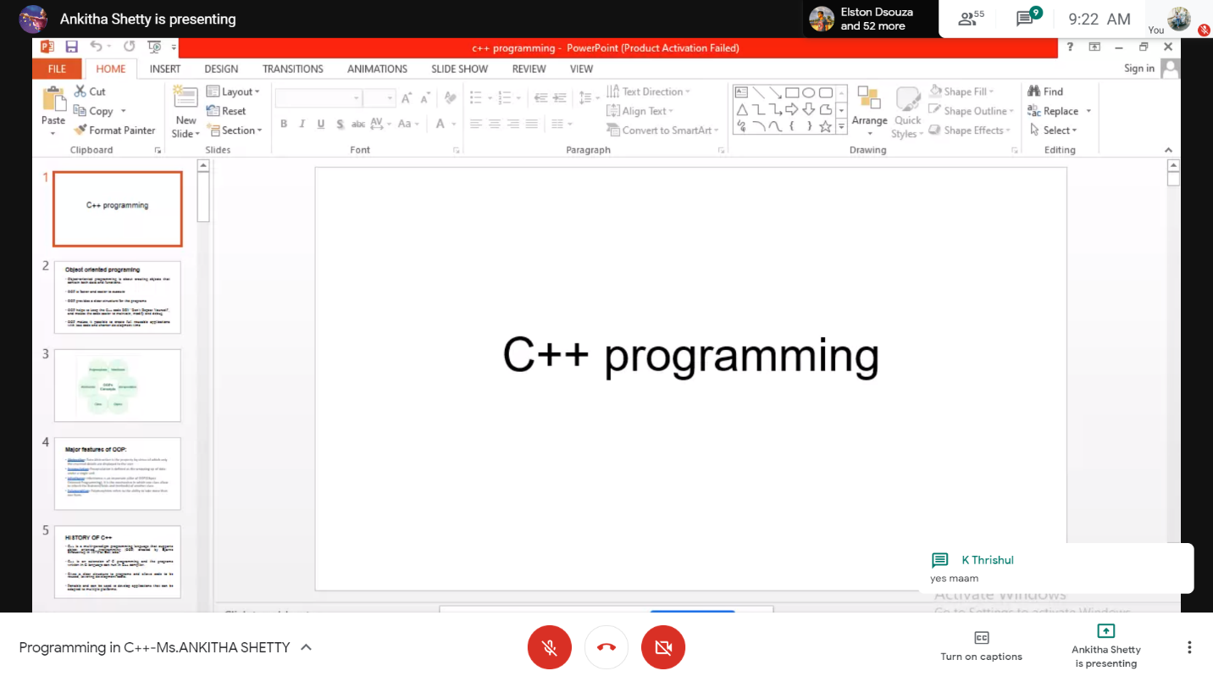

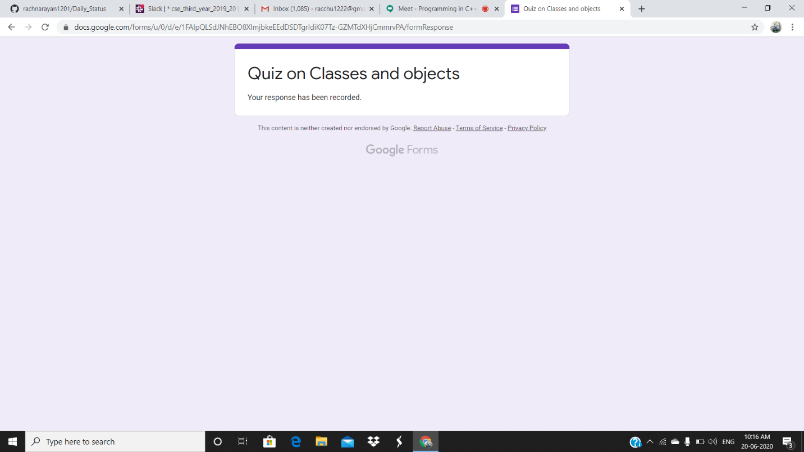

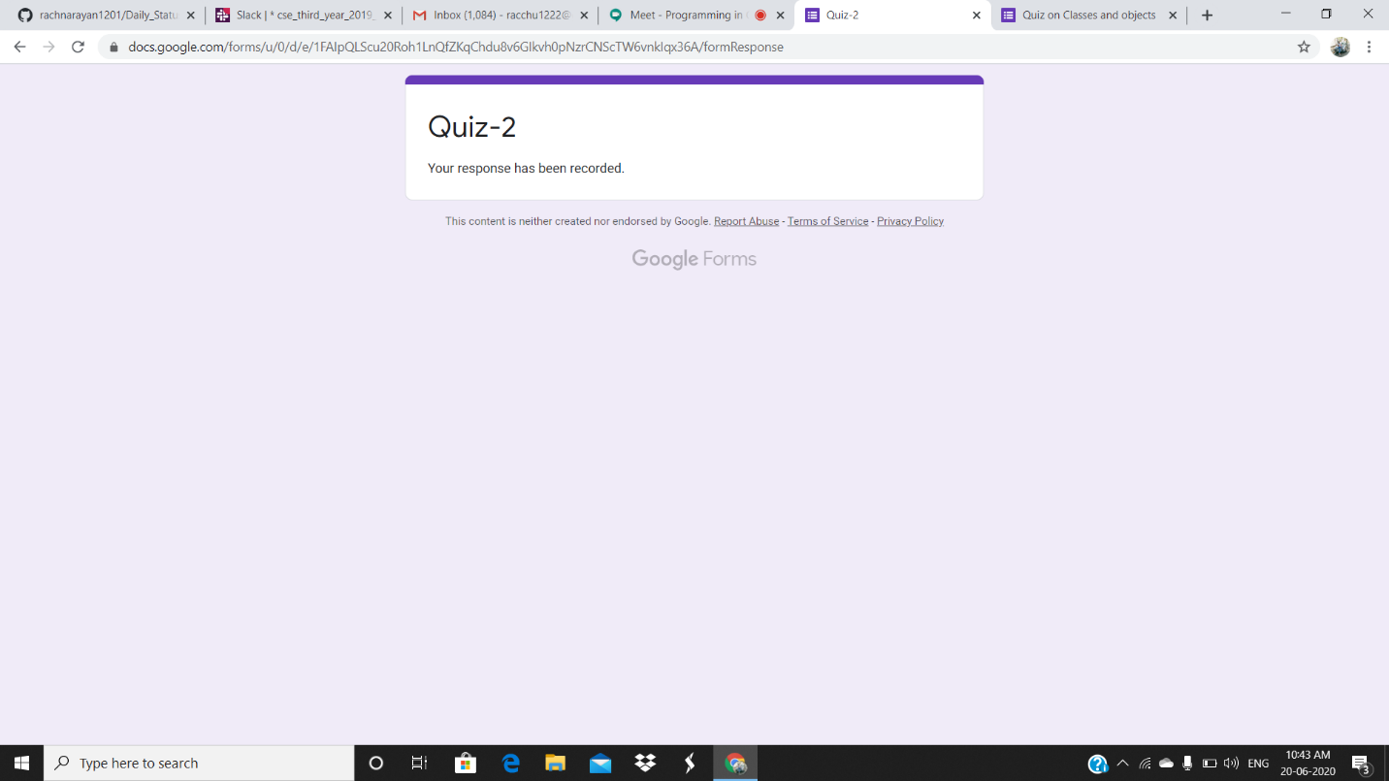

Refer the github link for example programs and exercise programs: https://github.com/rachnarayan1201/workshop-python-programming-exercises

**Coding Challenges Details:**

Refer the github link for detail information : **https://github.com/rachnarayan1201/daily_status_coding**

Solved all the problems and the solutions are uploaded in github account

The same report is also available in github: https://github.com/rachnarayan1201/Daily_Status